1. **Route 53**

**What is DNS?**

Domain Name System which translates the human friendly hostnames into the machine IP address.

[www.google.com](http://www.google.com) => 172.217.18.36

DNS is the backbone of the internet i.e. it translates hostnames into Ips

In AWS, DNS is managed using **Amazon Route 53**, a service that helps connect domain names to AWS resources like websites, applications, or storage. For example, if you have a website hosted on AWS, you can use Route 53 to make it accessible at www.mywebsite.com. It also ensures users are directed to the fastest or closest server and keeps things running smoothly if something goes wrong. Without Route 53, users would have to type in long, hard-to-remember IP addresses to access your site.

**DNS Terminologies:**

* Domain Registrar: A **domain registrar** is like a store where you buy and manage your website’s name, such as mybusiness.com. It’s needed because without registering a domain, no one can find your site using that name. For example, registering mybusiness.com through a registrar like Route 53 or GoDaddy ensures you own it and can connect it to your website. We should register because all domain name must be unique
* DNS Records: **DNS records** are instructions that tell the internet where to send traffic for your domain. For example, an **A Record** says, “Send visitors to this IP address (192.0.2.1) when they type example.com.” Without these records, your domain wouldn’t know where to send users, making your website or services inaccessible. Similarly, a **CNAME Record** acts as an alias, saying, “When visitors type www.example.com, redirect them to example.com.” This is useful for creating subdomains or redirecting traffic without duplicating DNS settings.
* Zone File: A **zone file** is a list of all the DNS records for a domain. It’s like a directory that tells DNS servers how to handle different requests. Imagine you run a bakery called "SweetTreats" with the domain sweettreats.com. The **zone file** acts like a guidebook that tells the internet what to do when someone interacts with your domain. For example, when a customer type sweettreats.com in their browser, the zone file directs them to your website at a specific address (like 192.0.2.1), and when someone emails orders@sweettreats.com, it sends the message to your email server (like mail.sweettreats.com). Without the zone file, the internet wouldn’t know where to send people or emails for your domain.
* Name Server: A **name server** stores and responds to DNS queries, translating domain names into IP addresses. Think of a **name server** like a phone book for the internet. Imagine you want to call your friend, but instead of remembering their phone number, you just know their name. You call a directory service (the name server), and it looks up the number for you. For example, when someone types example.com into a browser, the name server looks up the IP address for that website and tells the browser where to go. Without the name server, you'd have to remember and type in long, complicated numbers instead of simple domain names to visit websites.
* Top Level Domain: A **Top-Level Domain (TLD)** is the last part of a domain name, like .com in example.com. It categorizes domains into groups (e.g., .com for commercial, .edu for education). TLDs are required to organize domain names globally. For example, example.com and example.org can exist independently due to their different TLDs, ensuring uniqueness.
* 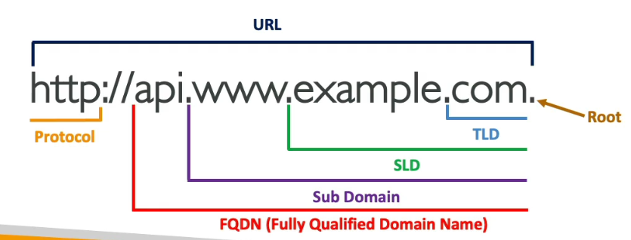Secondary Level Domain: The **Second-Level Domain (SLD)** is the part of a domain directly before the TLD, like example in example.com. It identifies the organization or entity using the domain. Without the SLD, domains would lack meaning. For instance, mybusiness.com specifies your business under the .com TLD, making it uniquely yours and recognizable to users.

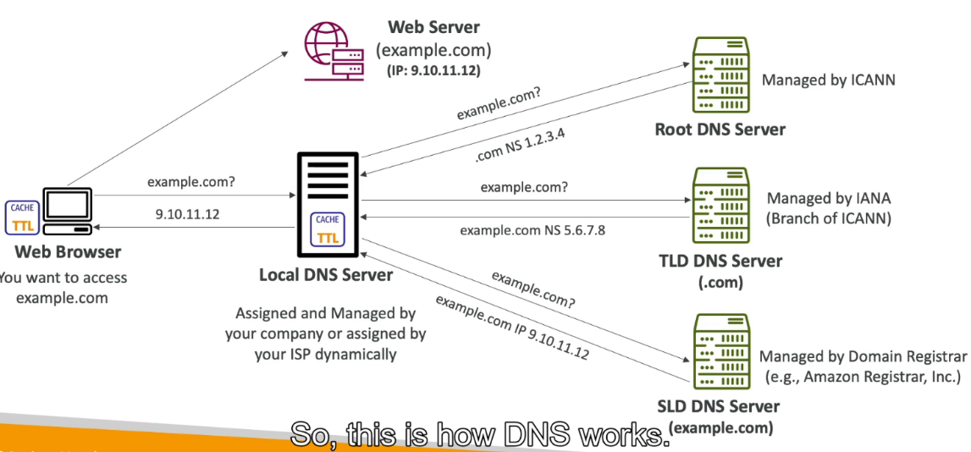How DNS Works?

When you type a website address like example.com into your web browser, the browser first checks its cache to see if it already knows the IP address. If it doesn’t, it sends a request to the **local DNS server** (usually provided by your internet service provider). The local DNS server then checks if it has the address in its cache; if not, it starts the process of looking it up. First, the local DNS server asks the **root DNS server**, which points to the **TLD DNS server** (for example, .com for example.com). The TLD server then directs the query to the **SLD DNS server** (the authoritative server for example.com), which holds the actual IP address of the web server hosting the site. The local DNS server then caches this IP address for a set time (defined by the **TTL**, or time-to-live) to speed up future requests. Finally, the local DNS server sends the IP address back to your web browser, which uses it to connect to the **public web server** and display the website.

**Amazon Route 53**

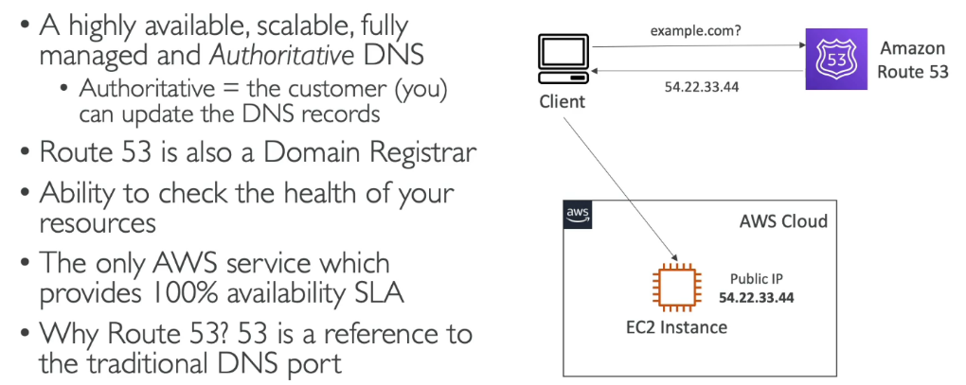**Amazon Route 53** is a scalable and highly available Domain Name System (DNS) service offered by AWS, designed to route end-user requests to AWS resources and other services across the internet.

**Route 53 – Records**

**Route 53 records** are DNS records used to map domain names to various resources, such as web servers or email services. The most common record types include **A Records** (which map a domain to an IPv4 address), **AAAA Records** (for IPv6 addresses), **CNAME Records** (which alias one domain to another), and **MX Records** (for email routing).

Route 53 also offers **Alias Records**, which are like CNAME records but can map domain names to AWS resources like CloudFront distributions or S3 buckets without using IP addresses.

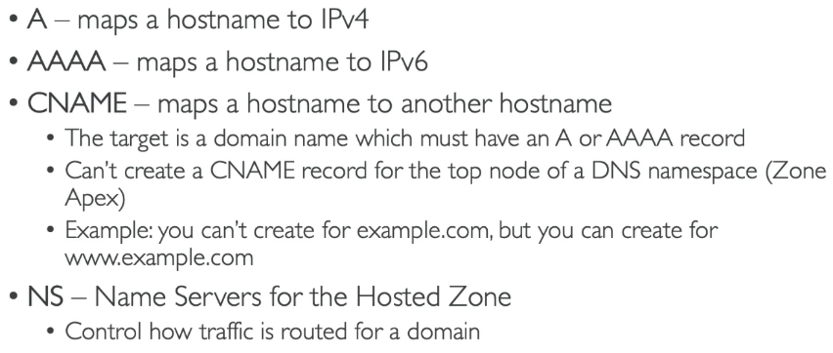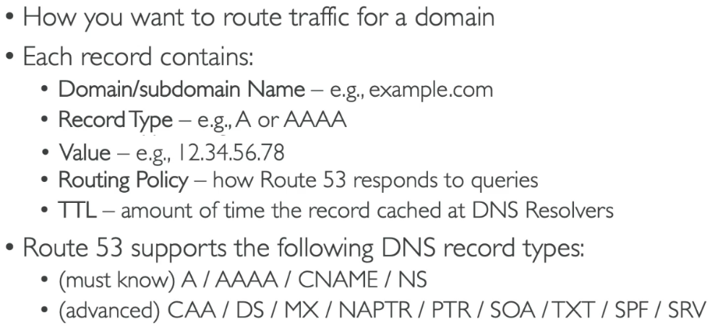**Record Types**

**Hosted Zones**

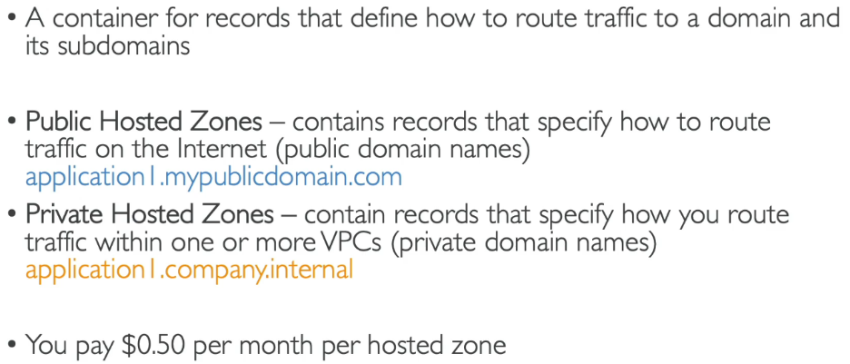A **hosted zone** in AWS Route 53 is a container that holds information about how you want to route traffic for a specific domain (e.g., example.com) and its subdomains.

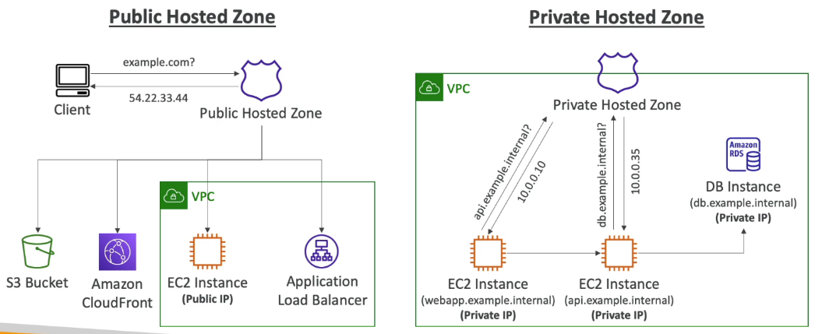

**TTL(Time to Live)**

**Time to Live (TTL)** in DNS is the duration (in seconds) that a DNS record is cached by a resolver or client before it queries the authoritative DNS server for updated information. TTL determines how frequently changes to DNS records propagate across the internet. A lower TTL (e.g., 300 seconds) ensures updates are reflected quickly but increases query load on authoritative servers, whereas a higher TTL (e.g., 86400 seconds) reduces server load and speeds up lookups but delays updates.

**High TTL:** A **high TTL** means DNS information is cached for a longer time, reducing the need for frequent lookups, which can improve performance and reduce server load. For example, if a website’s A record has a TTL of 86400 seconds (24 hours), any changes to its IP address will take up to 24 hours to update globally. This is ideal for websites with stable IPs.

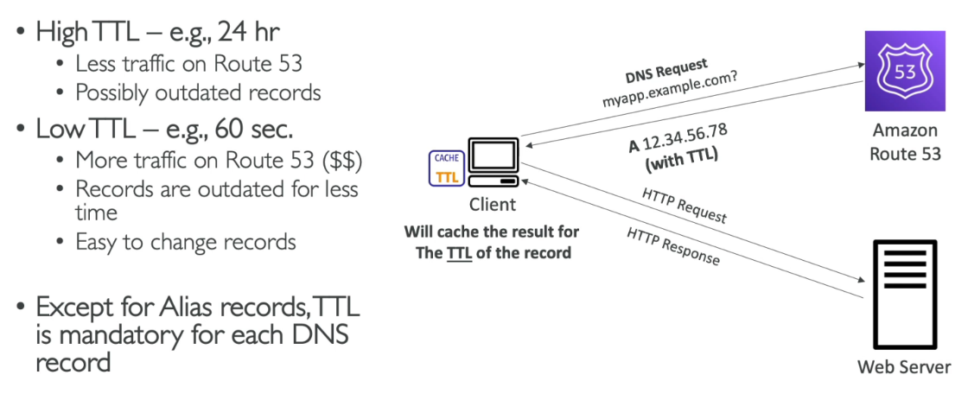**Low TTL:** A **low TTL**, like 300 seconds (5 minutes), updates DNS information quickly, which is useful for frequently changing resources, such as during a server migration or disaster recovery. For instance, if you’re moving your website to a new server, a low TTL ensures users are directed to the new server much faster, minimizing downtime. The trade-off is that low TTLs result in more frequent DNS lookups, which can increase load on DNS servers.

**CNAME vs Alias**

|  |  |  |
| --- | --- | --- |
| Feature | CNAME | Alias |
| Purpose | Maps one domain name to another domain name. | Maps a domain name to AWS resources (e.g., ELB, CloudFront). |
| Target | Must point to another domain name (e.g., www.example.com). | Can point to AWS resources or another domain name. |
| Root Domain (e.g., example.com) | Cannot be used for root domains. | Can be used for root domains. |
| Supported Services | Works universally with DNS systems. | Specific to Route 53 and AWS services. |
| DNS Query Cost | Regular DNS query costs apply. | No extra cost for queries; resolved internally in Route 53. |

A **CNAME (Canonical Name)** record maps from one domain name to another domain name. For example, if you have a domain blog.example.com and you want it to point to a third-party service like example.wordpress.com, you use a CNAME record. However, a key limitation is that a CNAME record **cannot be used for root domains** (like example.com); it only works for subdomains.

You own example.com and want your blog hosted on WordPress. You set up a CNAME record for blog.example.com pointing to example.wordpress.com. When users visit blog.example.com, they are routed to the WordPress-hosted blog.

An **Alias** record is a Route 53-specific feature that functions similarly to a CNAME but is designed to handle AWS resources and support root domains. Alias records can point to AWS services like Elastic Load Balancers (ELB), CloudFront distributions, or S3 buckets configured as websites. Unlike CNAME, Alias records work for both **root domains** and subdomains, and they automatically adjust if the target AWS resource's IP address changes.

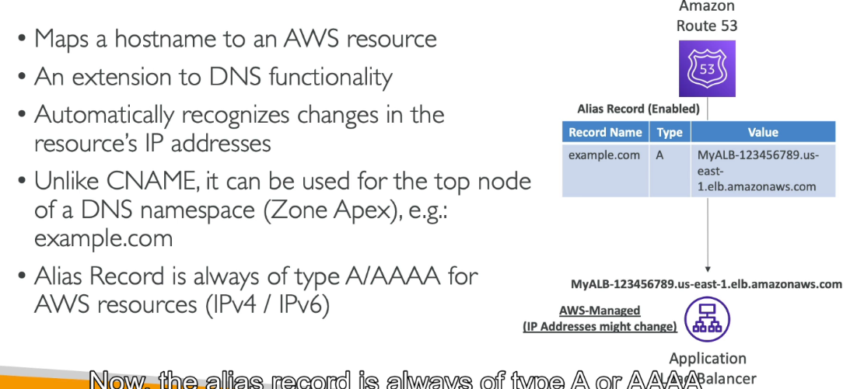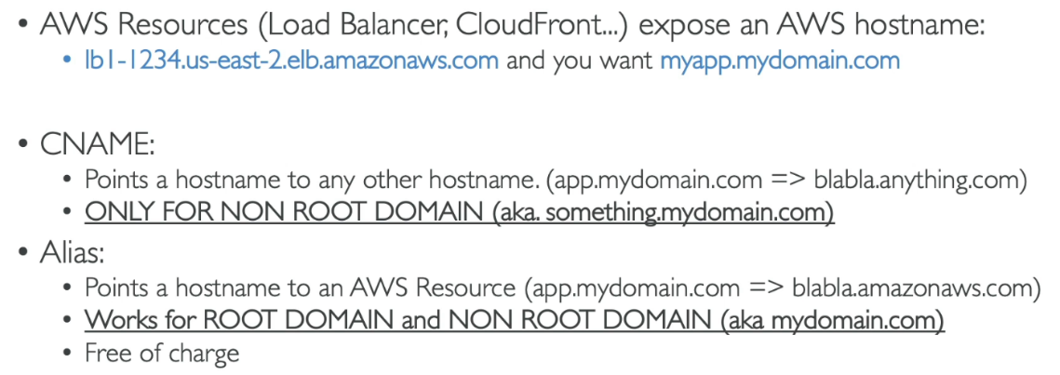

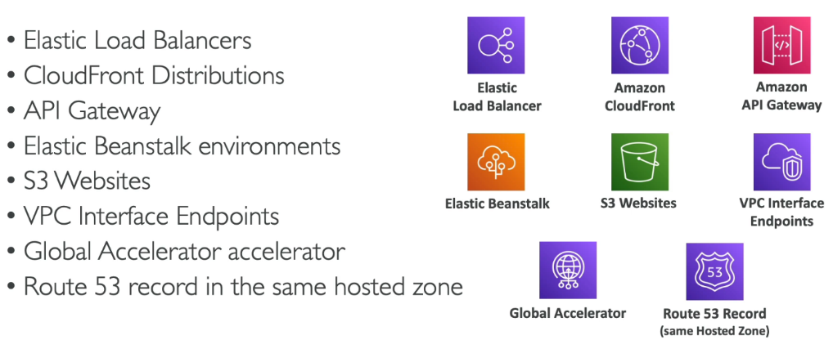**Alias Records Targets:**

**You cannot set an ALIAS for an EC2 DNS Name**

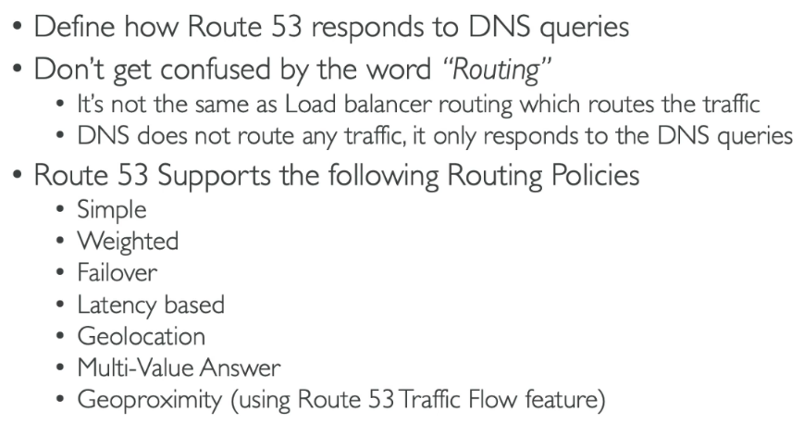**Route 53 – Routing Policies**

**Routing policies in AWS Route 53** are configurations that determine how DNS queries are resolved and direct user traffic to resources. They are designed to optimize traffic flow, ensure availability, and improve performance based on specific requirements.

**Simple Routing Policy**

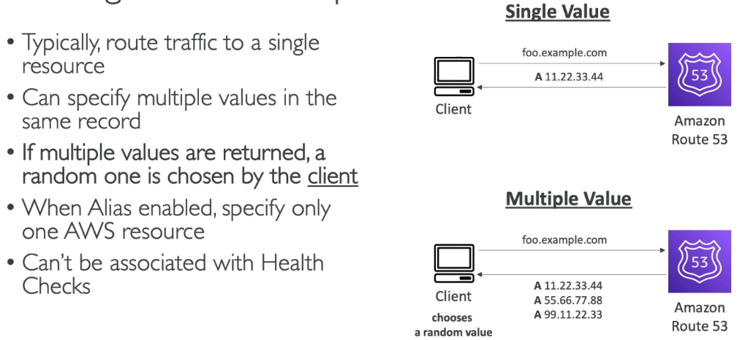The **Simple Routing Policy** in AWS Route 53 is the most straightforward routing policy, used to map a DNS domain name (like example.com) to a single resource, such as an EC2 instance, an S3 bucket, or a load balancer.

**Weighted Routing Policy**

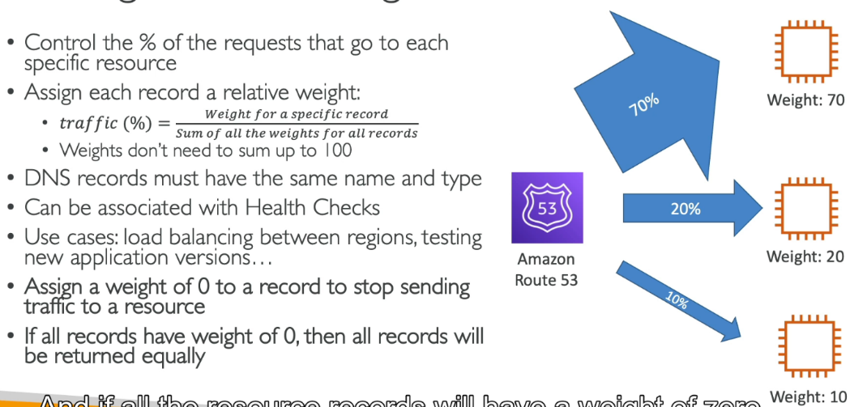The **Weighted Routing Policy** in AWS Route 53 allows you to distribute traffic across multiple resources based on pre-assigned weights. Each resource is given a numerical weight, and Route 53 uses these weights to determine the proportion of traffic routed to each resource.

**Latency Based Policy**

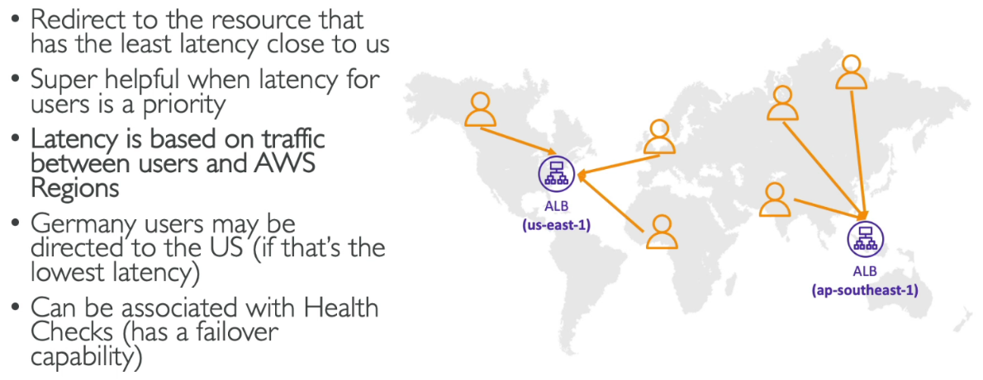The **Latency-Based Routing Policy** in AWS Route 53 directs traffic to the resource (e.g., an EC2 instance or load balancer) that provides the lowest network latency for the user making the DNS query. This policy improves application performance by ensuring users are connected to the nearest or fastest-performing endpoint, based on measurements of latency between AWS regions and the user's location.

**Health Checks**

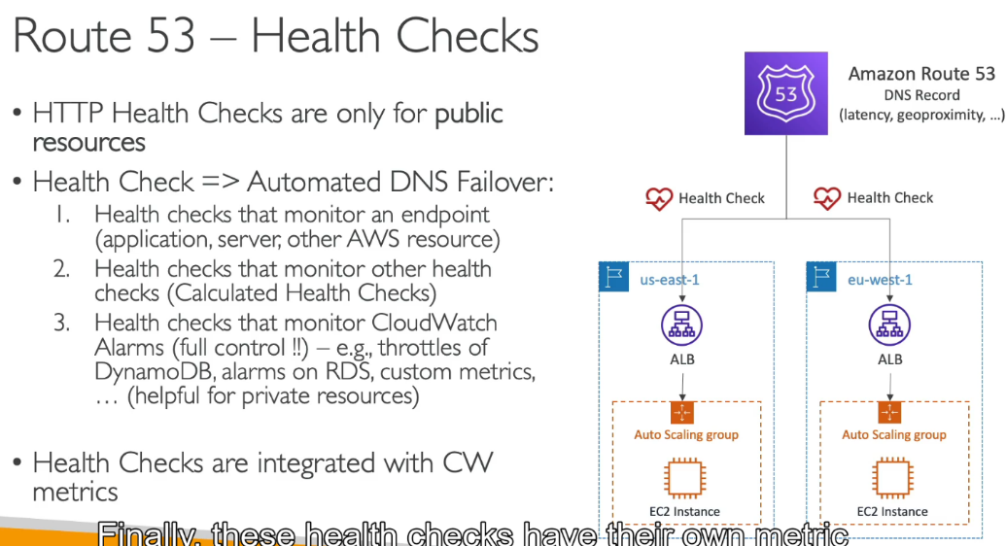**Health checks** in AWS Route 53 monitor the status of your resources (such as web servers, endpoints, or applications) and help ensure that DNS queries are routed only to healthy resources. They work by periodically sending requests to specified endpoints (e.g., HTTP, HTTPS, or TCP) and evaluating the responses.

Health checks integrated with **CloudWatch metrics** provide detailed monitoring and insights into the health of your resources in AWS Route 53. When you create a health check, Route 53 automatically generates **CloudWatch metrics** that track the results of the health check over time, including the percentage of healthy responses, latency, and the number of failed health checks. These metrics allow you to visualize trends, detect issues early, and set up alerts.

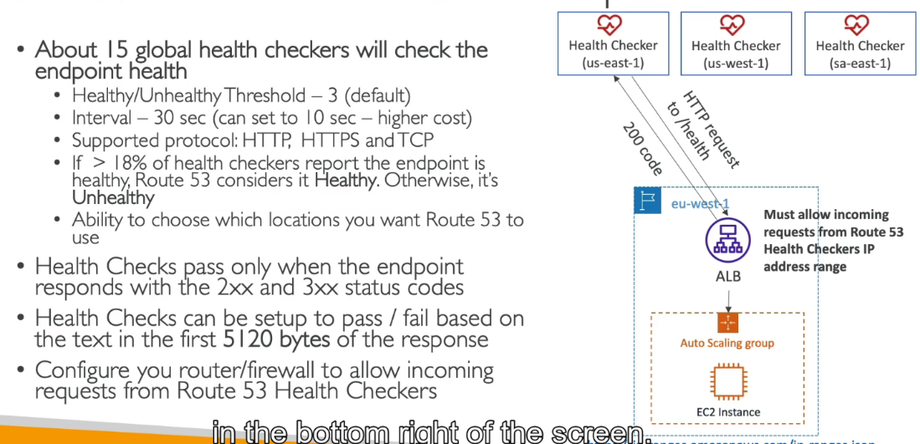By default, **15 global health checkers** distributed across different AWS regions worldwide are used to monitor an endpoint. This distributed system ensures reliable and consistent health monitoring from various geographic locations.

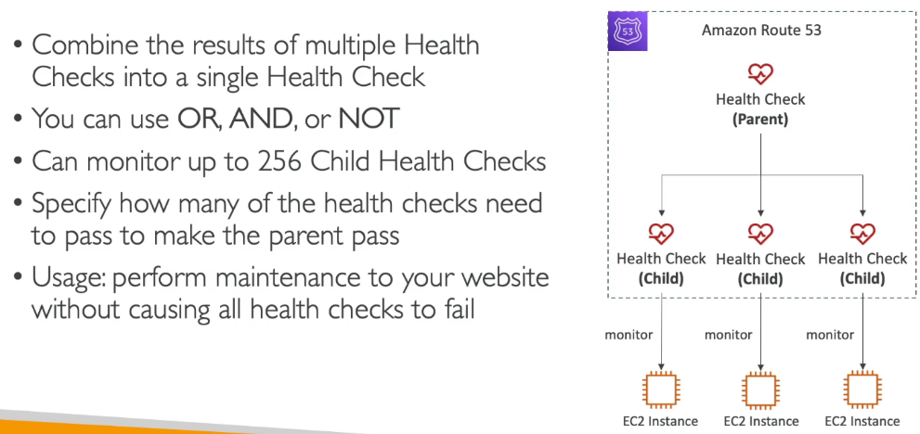**Calculated Health Checks**

**Private Hosted Zones**

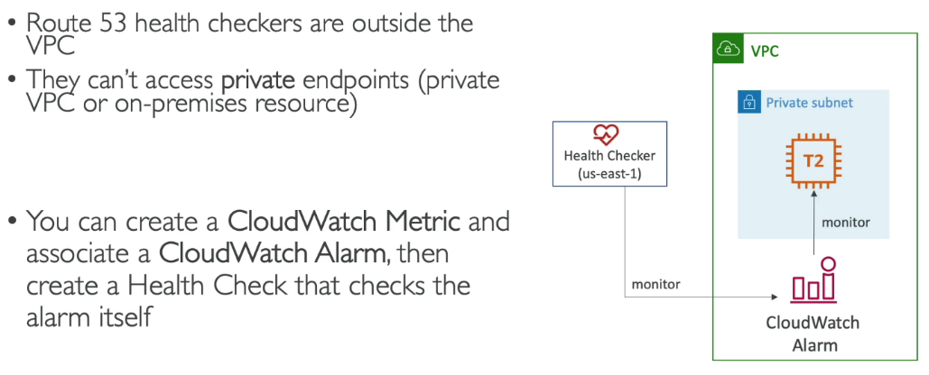A **Private Hosted Zone** in Amazon Route 53 is a DNS service that allows you to manage domain names and their associated records within a specific Amazon Virtual Private Cloud (VPC). It ensures that DNS queries for the hosted zone are accessible only within the VPC, offering a secure, isolated environment for resources like EC2 instances, databases, or internal applications.

**Failover(Active-Passive) Based Policy**

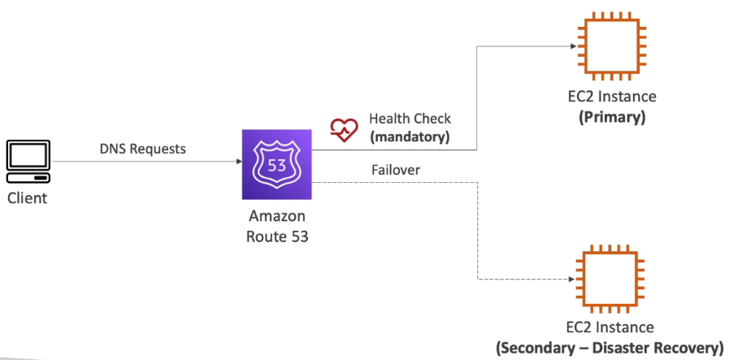A **failover-based routing policy** in Amazon Route 53 is designed to enhance the availability and reliability of your applications by directing traffic to healthy resources. This policy requires two record sets: a primary and a secondary (or failover) resource.

**Geolocation Based Policy**

A **geolocation-based routing policy** in Amazon Route 53 directs user traffic to resources based on the geographic location of the user's query. This policy allows you to serve different content or services depending on the user's region, such as directing European users to servers in Europe for reduced latency or complying with regional regulations.

**Geolocation-Based Routing** focuses on user location, not network performance. It ensures compliance with regulations, serves localized content, or restricts access to certain regions. The nearest server may not always be the chosen one; routing follows rules based on geographic areas.

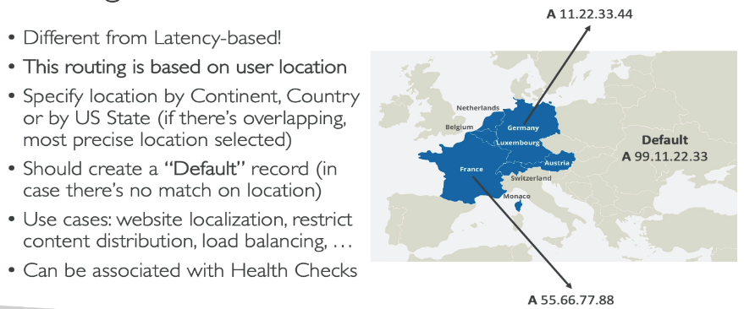Imagine a user in India accessing a website with servers in Singapore (closer) and Europe (farther). Under normal conditions, Singapore should provide lower latency due to proximity. However, if the network between India and Singapore is congested or experiencing issues, the connection to Europe might actually be faster despite the greater distance. Geolocation-based routing would still direct the user to Singapore based on location rules, while latency-based routing would send them to Europe for better performance, showing the distinction between the two approaches.

**Geoproximity Routing Policy**

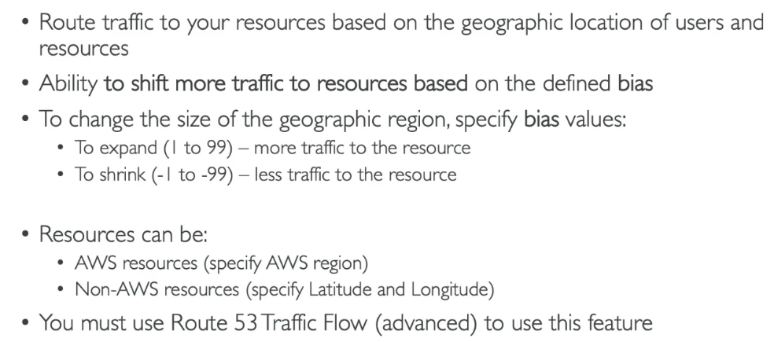A **geoproximity routing policy** in Amazon Route 53 routes traffic based on the location of users and resources, with added control using a "bias" setting. A **bias setting** in geoproximity routing allows you to adjust how much traffic is directed to a resource by expanding or shrinking the geographic area it serves.

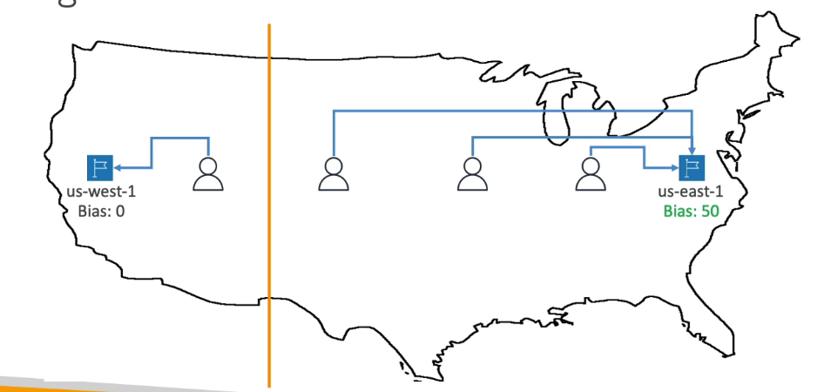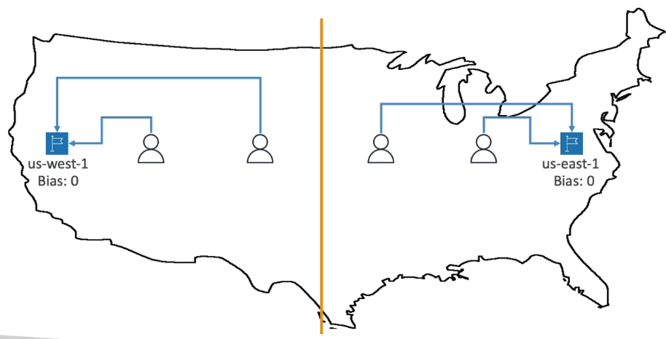

**IP Based Routing**

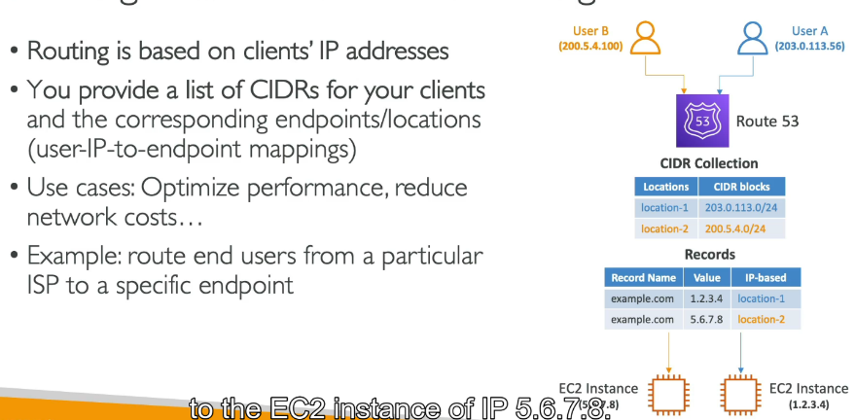**IP-based routing**, also known as **IP address-based routing**, in Amazon Route 53 allows you to route traffic to specific resources based on the source IP address of the user making the DNS query. With this method, you define rules that map specific CIDR IP ranges to corresponding resources.

**Multi-Value Based Policy**

A **multi-value routing policy** in Amazon Route 53 is used to improve availability and load balancing by allowing you to associate multiple resources (e.g., IP addresses, load balancers) with a single domain name. When a DNS query is made, Route 53 responds with up to eight healthy resource records, chosen randomly. This helps distribute traffic across multiple resources while avoiding unhealthy ones, as determined by health checks.

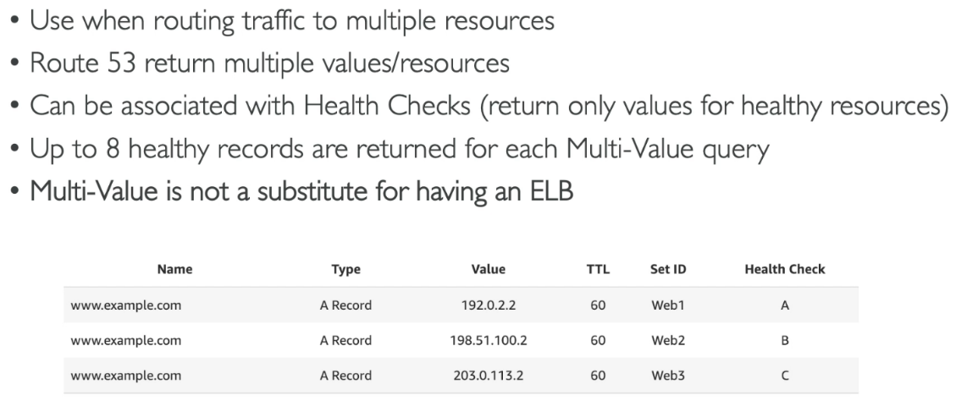

**Multi-Value Routing** distributes traffic by giving multiple healthy IPs to the user, letting their device choose where to connect, while **ELB** actively manages and balances traffic between servers within one region, with more advanced features like monitoring and traffic control.

**Domain Registrar vs. DNS Service**

|  |  |  |
| --- | --- | --- |
| Aspect | Domain Registrar | DNS Service |
| Purpose | Helps you register and manage domain names (e.g., example.com). | Translates domain names into IP addresses for user connections. |
| Function | Ensures ownership of the domain and renewals. | Manages DNS records like A, CNAME, MX, and TXT. |
| Example Providers | GoDaddy, Namecheap, Google Domains. | Amazon Route 53, Cloudflare, Google Cloud DNS. |
| Focus | Ownership and registration of domain names. | Efficient traffic routing and DNS resolution. |
| Integration | Can work with any DNS service. | Requires a registered domain name to function. |

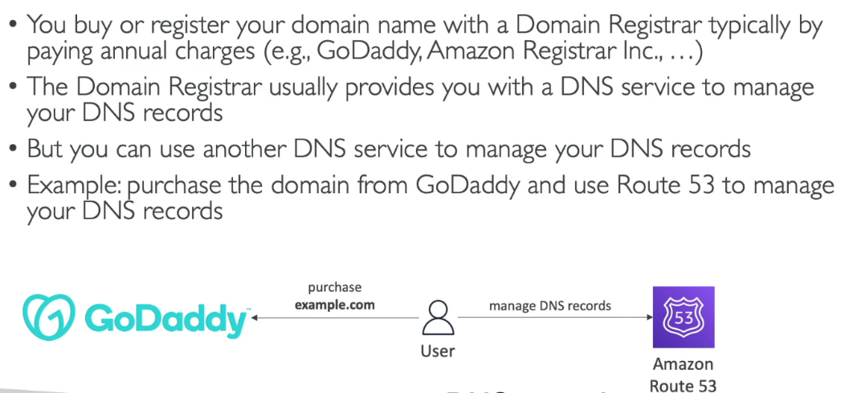

**How to use GoDaddy as registrar and Route53 as a DNS Service**

To use **GoDaddy** as your domain registrar and **Amazon Route 53** as your DNS service, first register your domain with GoDaddy. Then, in the AWS Management Console, create a **hosted zone** in Route 53 for your domain, which will generate **Name Server (NS)** records. Next, log into your GoDaddy account, go to the domain's DNS settings, and update the **Name Servers** to the ones provided by Route 53. Once the DNS changes propagate (which may take up to 48 hours), configure DNS records in Route 53 (such as A, CNAME, or MX) to point your domain to the appropriate resources, like a website or server. This setup ensures GoDaddy manages domain registration while Route 53 handles DNS resolution.

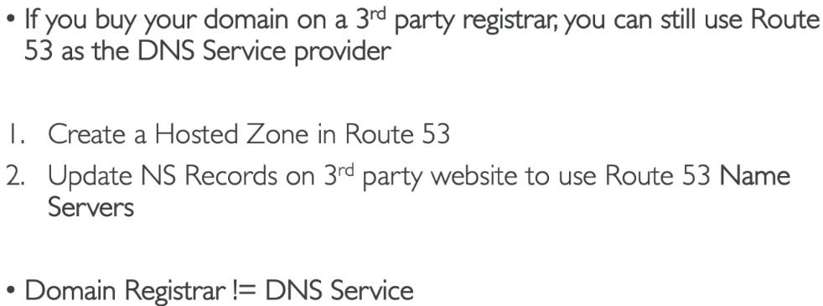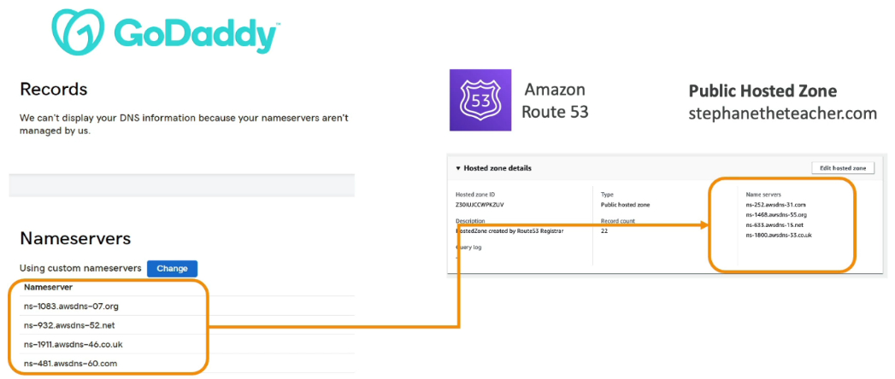

1. **Solution Architecture Discussion Overview**

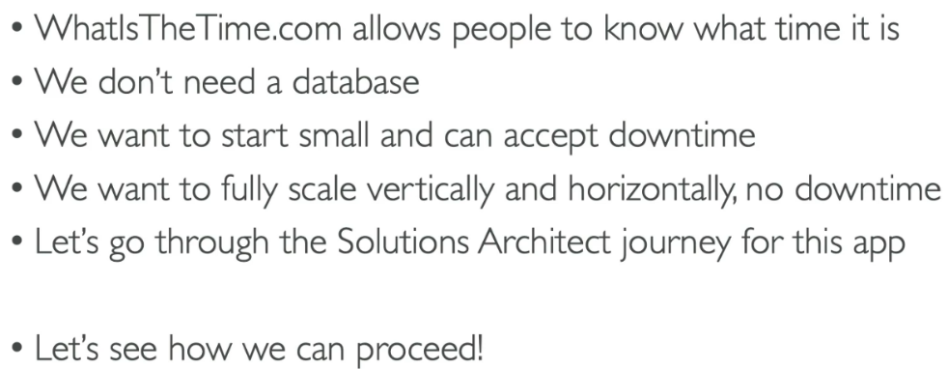**Stateless Web App: WhatIsTheTime.com**

* You’re a solution architect, you need to make whatismy time.com
* 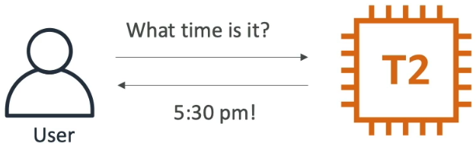You will use a public ec2 instance with elastic IP so that user can know what time is it
* 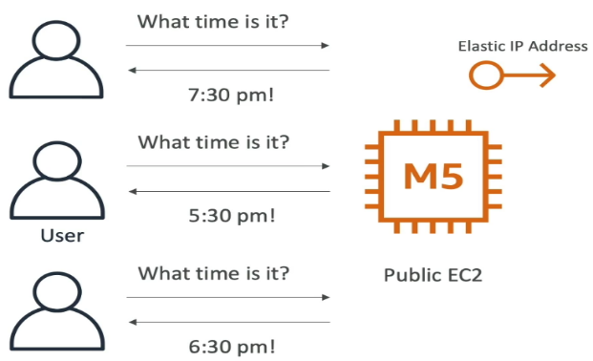If some more friends comes in and say what time is it then our application is getting more traffic and t2 micro instance. The app is slow because the instance's CPU or RAM is maxed out. If the app struggles with heavy computations (e.g., converting multiple time zones)We should do vertical scaling stopping the instance, change the instance type to M5.
* 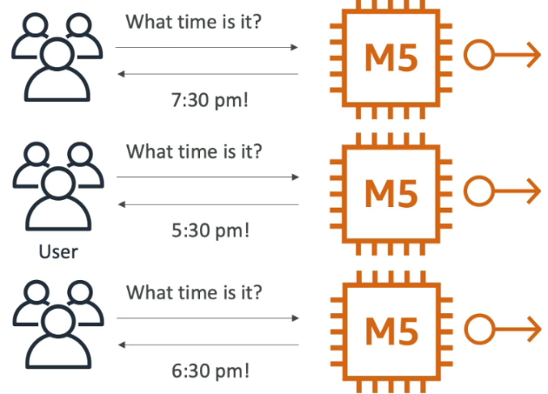Now User traffic spikes, and a single instance can't handle all requests. So we need to scale it horizontally all have elastic IP attached to it.
* 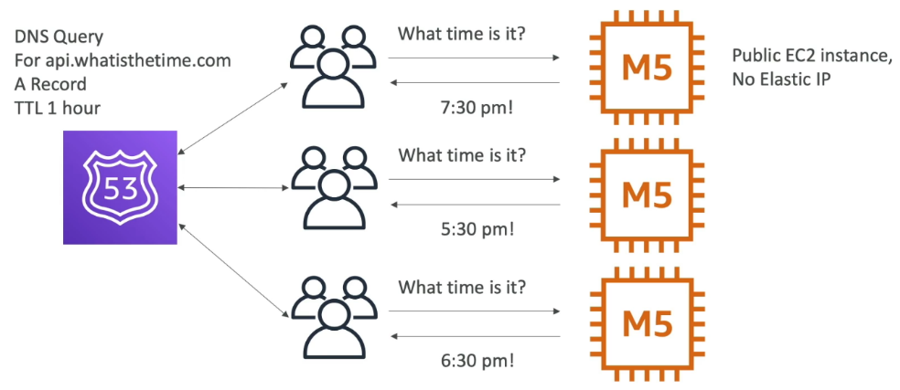Now users need to be aware of these three Elastic IPs so there comes the problem. So lets change the approach. We are going to add Route53 of domain api.whatisthetime.com of A record which gives the Ips.
* 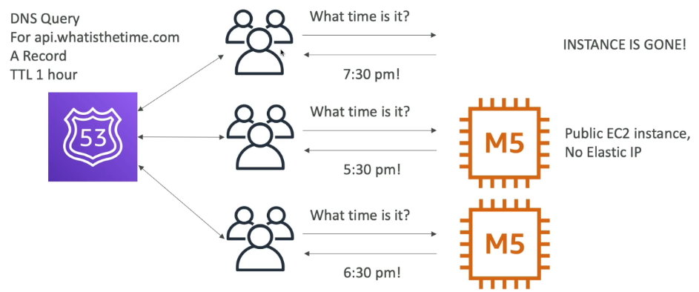Now we need to add and remove instance on flight . Suppose the instance is gone but the TTL is 1 hour so for 1 hour the user accessing the ec2 instance is shut down.

Now we should add a load balancer

* 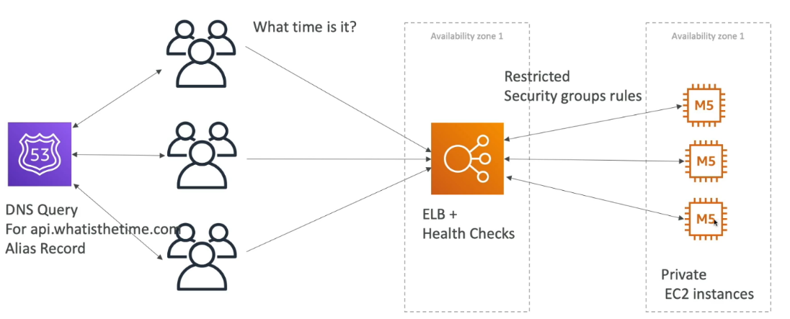Now we should create a private ec2 instance and attach Elastic Load Balancer with Health Checks with restricted Security Group . the DNS Query will be linked to the ELB using ALIAS not A record Since the IP of the ELB is constantly Changing. We make EC2 instances private when using an ELB to improve security. The ELB handles all public traffic, so the instances are hidden from the internet, reducing the risk of attacks while still receiving traffic safely through the ELB.
* 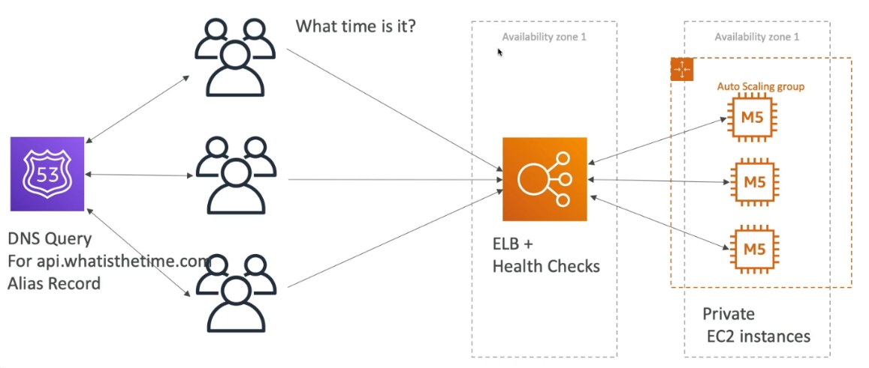But adding and removing Instances are hard to do. So, we will now launch an auto scaling group. The ec2 instances should be managed by the Auto Scaling Group
* 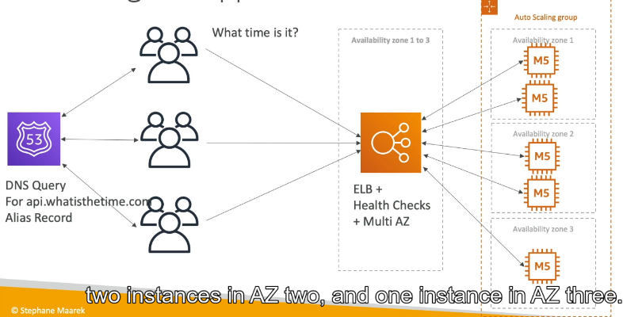Then there comes the scenario where the entire AZ1 fails down. So we need to implement the multi AZ.
* 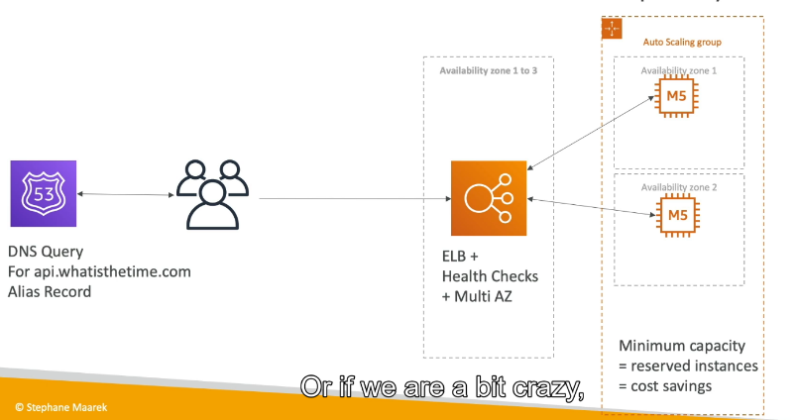Now we need to diminish the cost since 1 ec2 instance is enough for a availability zone. So we are going to reserve the capacity
* 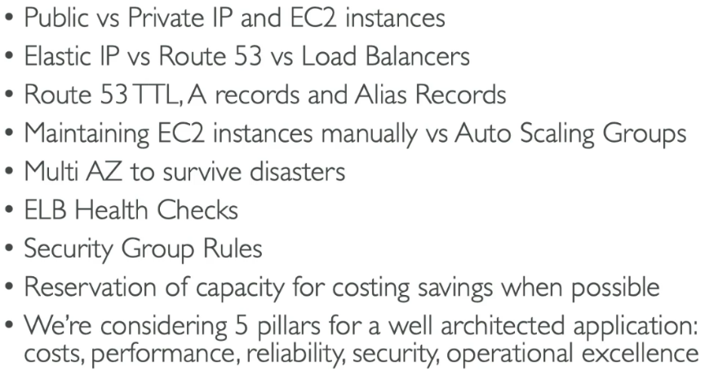**Summary**

**Application Setup:**

A load balancer (ELB) is used to distribute traffic across multiple EC2 instances to ensure no instance is overloaded.

Private EC2 instances handle the traffic, and security groups restrict communication between the load balancer and the instances.

**Traffic Management:**

Instead of using a regular A record, an alias record in Route 53 is used to point to the ELB, ensuring that DNS resolution works correctly even when the ELB's IP changes.

**Scaling the Application:**

Auto-Scaling Groups (ASG) are introduced to automatically scale the number of EC2 instances based on demand (e.g., more instances during high traffic times, fewer during low traffic).

The application can scale in and out without manual intervention, ensuring optimal resource usage.

**Ensuring Availability:**

The initial setup is vulnerable to failure in a single Availability Zone (AZ). If one AZ goes down, the application will be entirely unavailable.

To address this, the application is configured to use multi-AZ deployment, where instances are spread across multiple AZs. If one AZ fails, the others continue serving traffic.

**Cost Efficiency:**

The application uses reserved instances for a minimum number of EC2 instances, ensuring cost savings for baseline capacity.

Spot instances are used for non-critical or temporary scaling needs, offering lower costs but with the risk of termination.

**Improving Fault Tolerance and Resilience:**

The multi-AZ deployment ensures that the application remains highly available and resilient to failures like an AZ outage or disaster.

The system can continue running without downtime even during unexpected events.

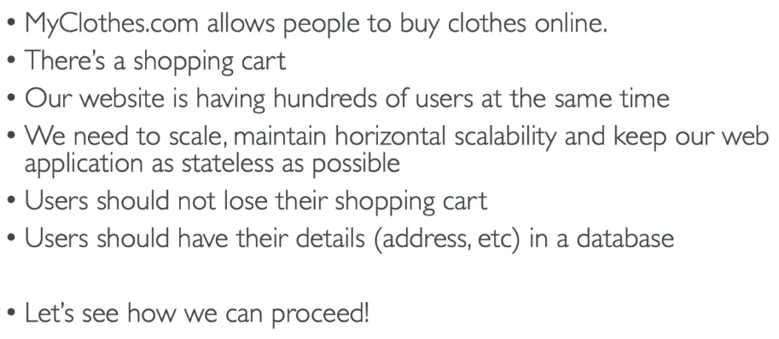 **Stateful Web Application : MyClothes.com**

* 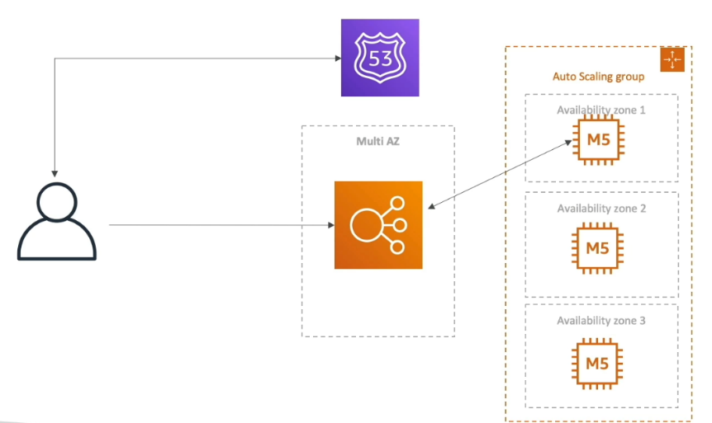Simple Setup
* 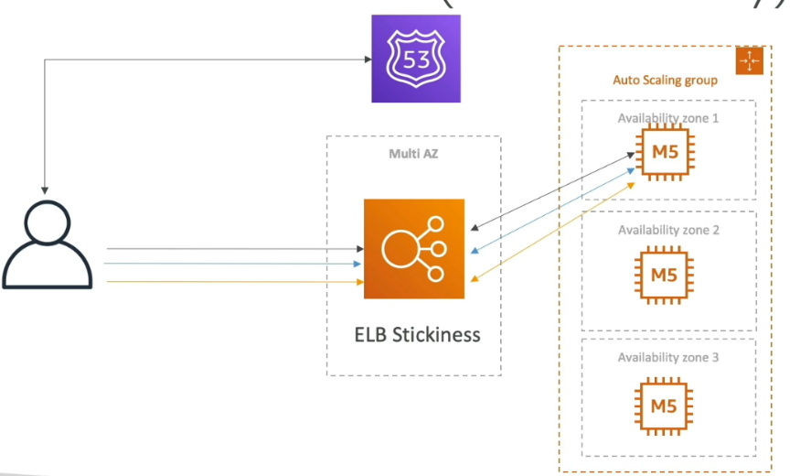If user create a shopping card, close app and reopen to another instance , the shopping card will be gone. For that we can use stickiness. Then every request go to the same EC2 instance.
* 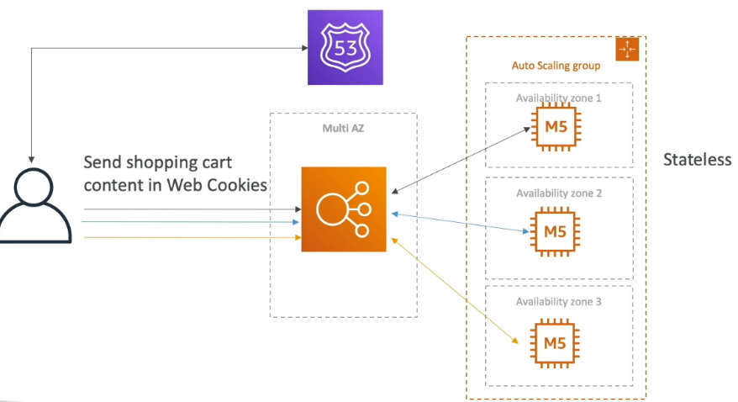 Let’s look the different approach . Instead of having the instance to store the shopping cart , the user can be sending the info of shopping card in the form of cookies.

But if we send more cookies day by day, the instance will get heavier and heavier because we are sending a shopping card content in the form of web cookies.

* 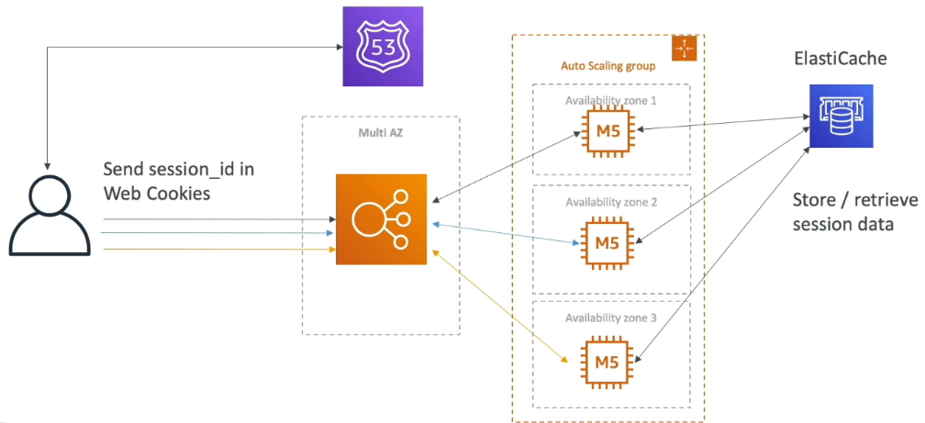Let’s introduce the concept of server session, instead of sending the whole shopping cart we will send the session_id . in the background we have a elastic cache cluster. Using an ElastiCache cluster for session management allows efficient and scalable storage of session data, such as shopping cart details, mapped to session IDs stored in cookies. Instead of sending the entire shopping cart data with each request, the session ID in the cookie acts as a lightweight reference. The ElastiCache cluster, typically leveraging Redis or Memcached, ensures low-latency access and high throughput for session data retrieval.
* 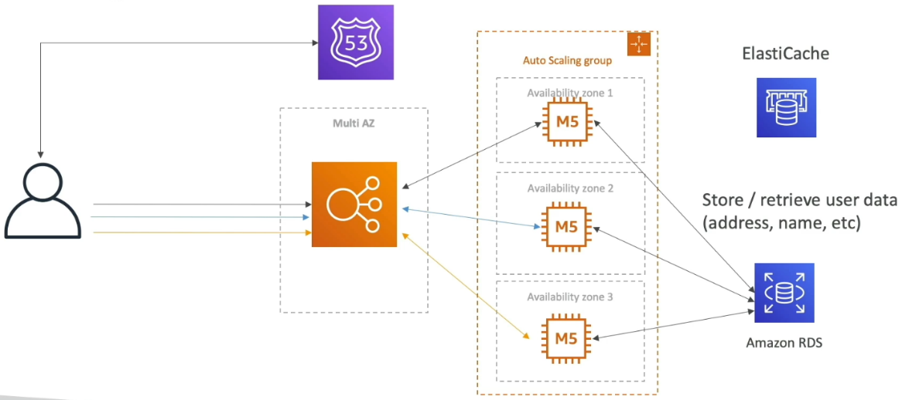To store the user info we have database.
* 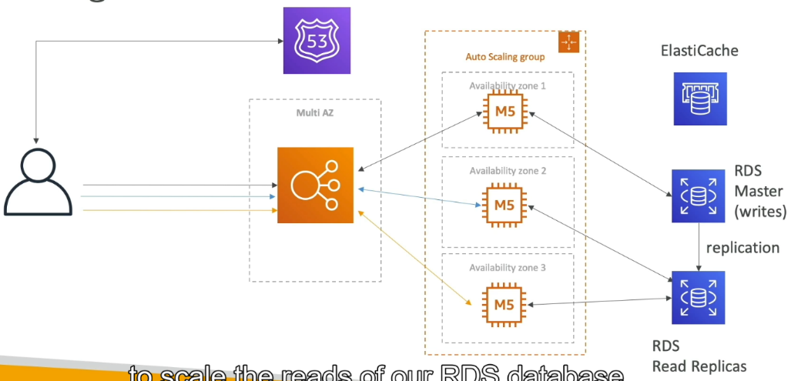If we have more and more users, then we create some read replicas which helps to scale our reads of rds. As the number of users increases, the demand for reading operations on the RDS database can become a bottleneck, impacting performance. To address this, read replicas are created, which are copies of the primary database that synchronize data in near real-time. These replicas handle heavy read workloads by distributing read queries across multiple replicas, reducing the load on the primary database and improving response times.
* 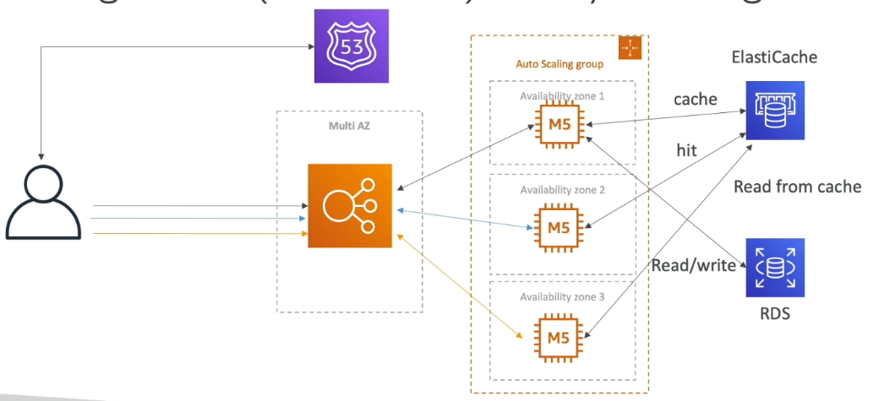There is another method called lazy loading. Lazy loading is a caching strategy where data is loaded into the cache only when it is requested for the first time. If a requested item is not found in the cache (a cache miss), it is retrieved from the primary data source, added to the cache, and then returned to the user. This approach ensures that only the most frequently accessed data is stored in the cache, optimizing memory usage and reducing unnecessary loading of infrequently used data.
* 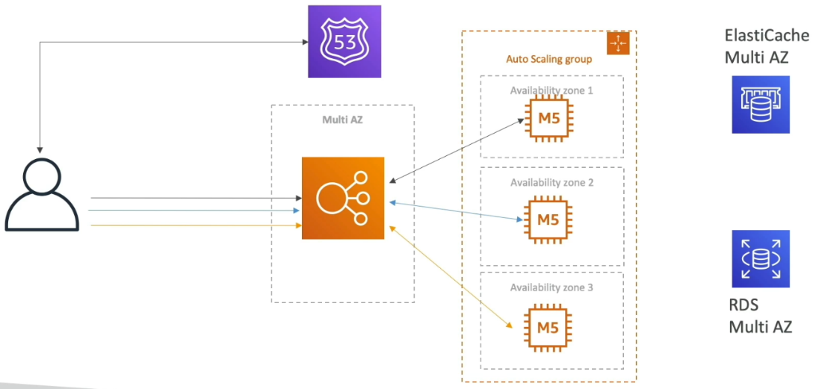To survive disasters, we need all the services Multi AZ
* 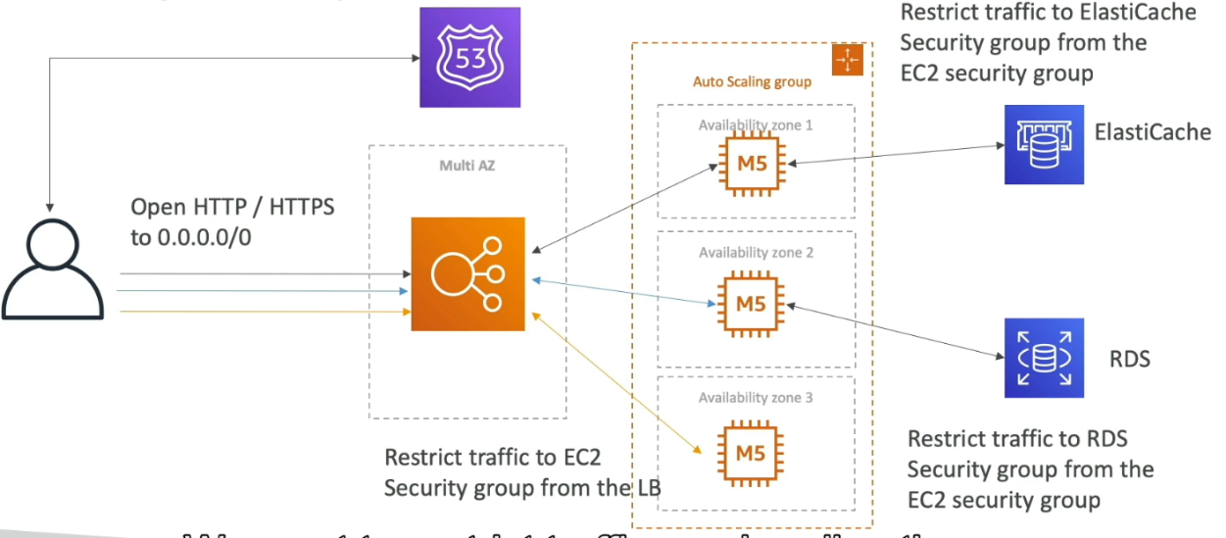Now for security reasons,

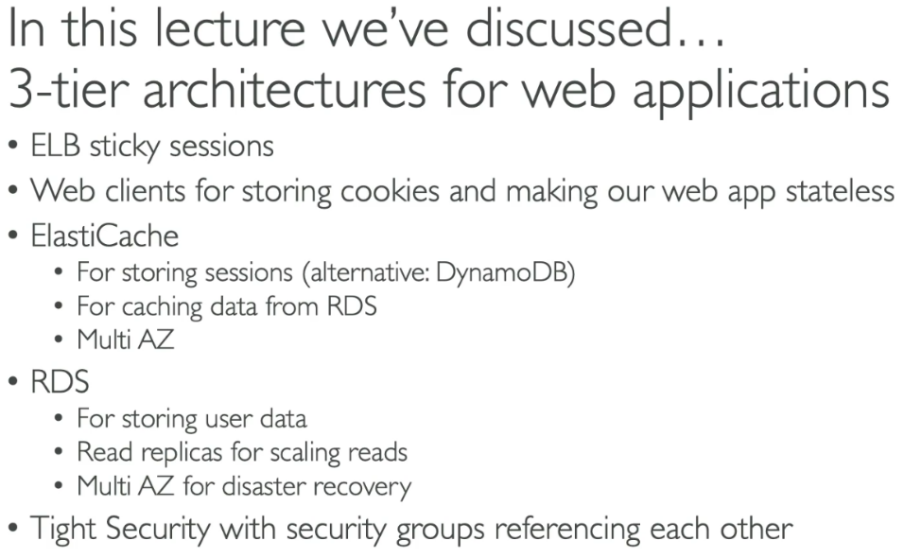

**Stateful Web App : MyWordPress.com**

* 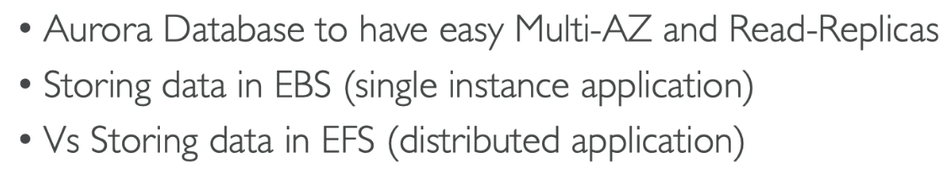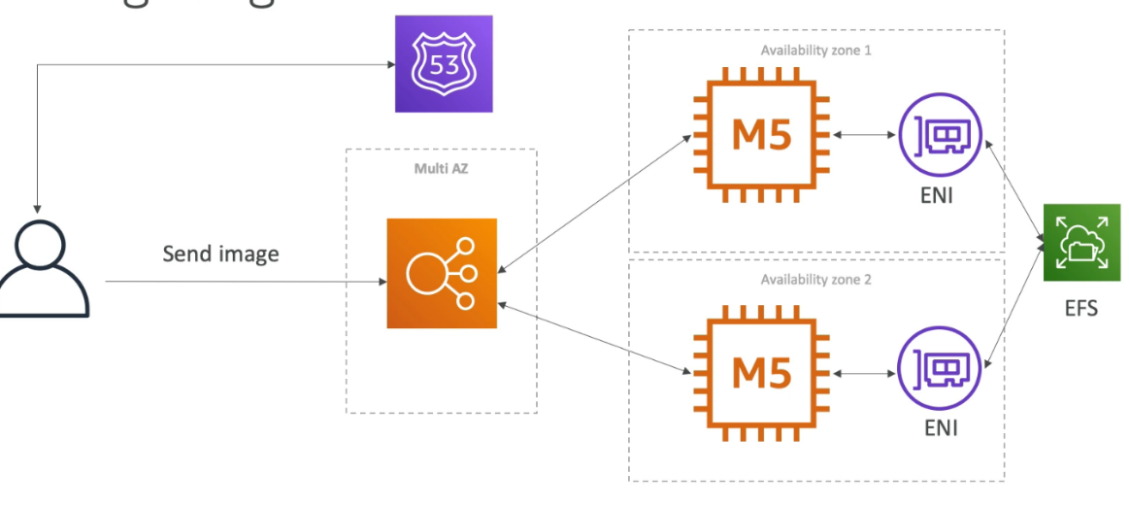For storage we will be using the EFS. . Unlike EBS, which is tied to a single EC2 instance and limited to the zone it resides in, EFS allows multiple EC2 instances across different availability zones to simultaneously access the same file system. This makes EFS ideal for applications requiring shared, scalable, and concurrent file access

**Instantiating Applications Quickly**

**Ec2 Instance:**

* Use a Golden AMI: A **Golden AMI** (Amazon Machine Image) is a pre-configured, standardized image of an EC2 instance that contains the operating system, application software, and configuration settings required for your application. By using a Golden AMI, you can quickly instantiate EC2 instances with the exact configuration and setup needed, eliminating the time-consuming process of manually installing and configuring software.
* Bootstrap Using User Data: **Bootstrap using user data** in EC2 instances refers to the process of automatically configuring an instance when it is launched, using custom scripts or commands provided in the user data field. This allows for automated setup tasks, such as installing software, configuring settings, or running custom scripts on the instance during the boot process.

**RDS Databases:**

* + Restore from a Snapshot: Restoring from a snapshot in the context of RDS (Relational Database Service) allows you to quickly instantiate an application by restoring a database to a specific point in time. A snapshot is essentially a backup of your RDS instance that captures the state of the database at the time it was taken.
  + Restore from a EBS snapshot: By recovering the EBS volume from a snapshot, you can quickly instantiate an RDS database with the same data and configurations it had when the snapshot was created.

**Elastic Beanstalk**

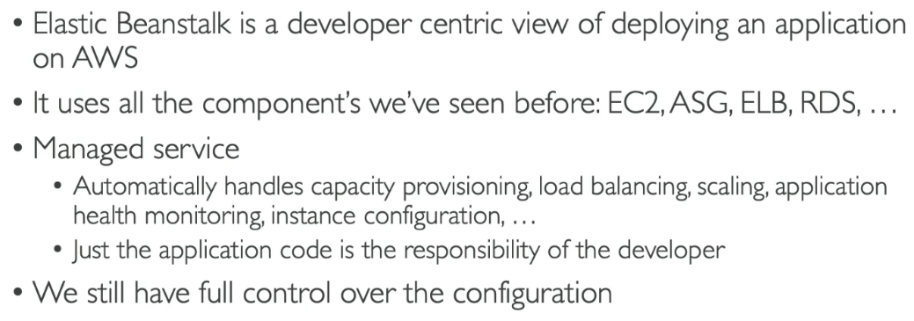AWS Elastic Beanstalk is a fully managed service that simplifies the deployment, scaling, and management of web applications and services. It automatically handles the infrastructure provisioning, load balancing, scaling, and application health monitoring, allowing developers to focus on writing code rather than managing servers. It is free but you need to pay for underlying resources.

**Elastic Beanstalk – Components**

* Application: An Application in Elastic Beanstalk is a container for your application’s source code and configuration. It represents the overall project and can contain multiple versions of your app. For example, a YouTube clone or a web service might be an application, and it can have different versions over time (e.g., version 1.0, 1.1, etc.).
* Application Version: An Application Version refers to a specific, labeled version of your application code. Each version represents a snapshot of the application’s source code, configurations, and dependencies that you upload to Elastic Beanstalk. You can deploy and manage different versions of your application, allowing you to roll back to a previous version or update to a new one. For example, a new feature added to your application might be version 1.1.
* 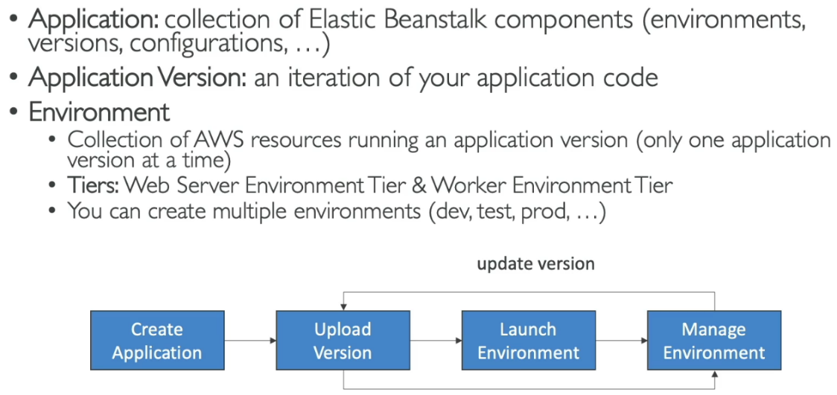Environment: An Environment in Elastic Beanstalk is a running instance of an application version in a specific configuration (like a production or staging environment). It consists of AWS resources such as EC2 instances, load balancers, security groups, and databases that are automatically provisioned and managed by Elastic Beanstalk. You can have multiple environments (e.g., a staging environment for testing new versions and a production environment for live users), each running different application versions.

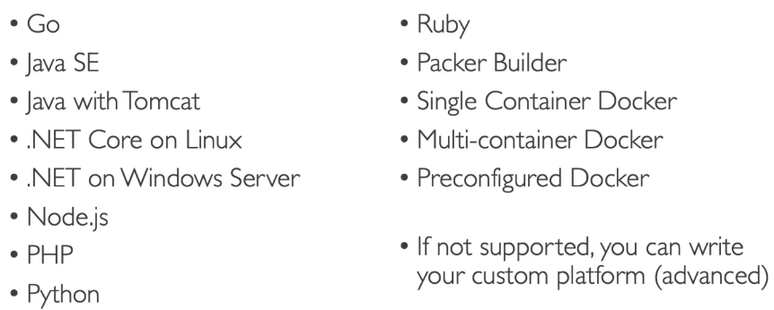**Supported Platform:**

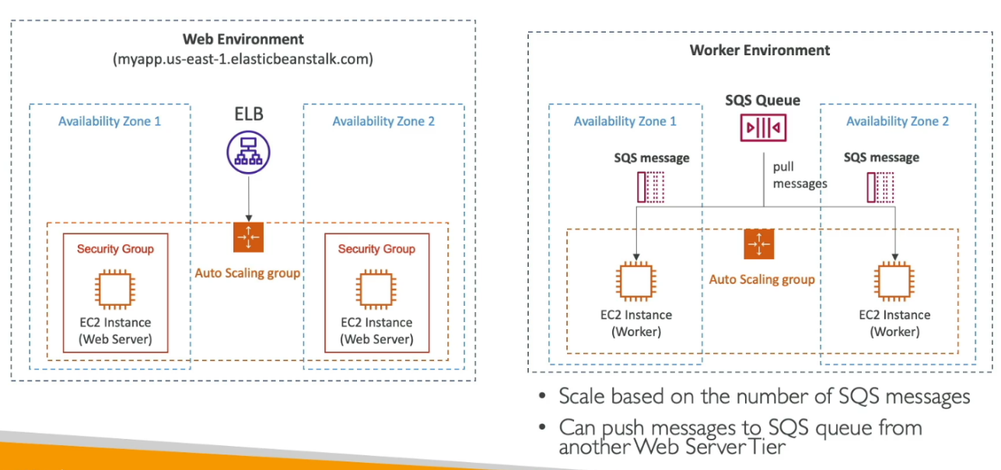**Difference Between Web Server vs. Worker Tier**

|  |  |  |
| --- | --- | --- |
| Feature | Web Server Tier | Worker Tier |
| Primary Purpose | Handles HTTP requests from users (web traffic). | Handles background tasks or jobs that run asynchronously. |
| Use Case | Suitable for applications with direct user interaction (e.g., websites, APIs). | Suitable for applications that need to process background tasks like sending emails, processing videos, or handling queues. |
| Instances | EC2 instances serve as web servers, responding to incoming HTTP requests. | EC2 instances act as workers that consume messages from queues and process background tasks. |
| Communication | Communicates with users through the internet (e.g., via an Elastic Load Balancer). | Communicates with the web server tier or other services via a message queue (e.g., Amazon SQS). |
| Scaling | Scales based on HTTP request load (e.g., web traffic). | Scales based on the number of tasks or jobs in the queue. |

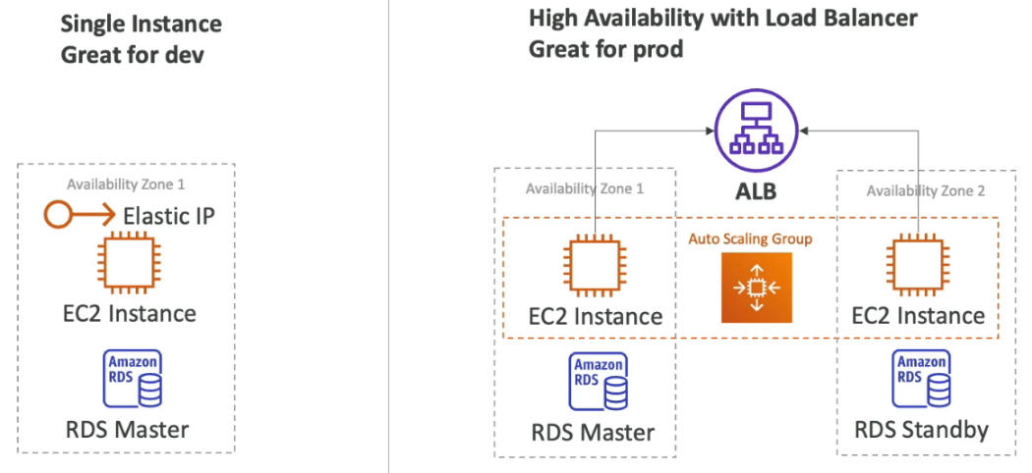 **Two Beanstalk Deployment Modes**

1. **Amazon S3**

**Overview**

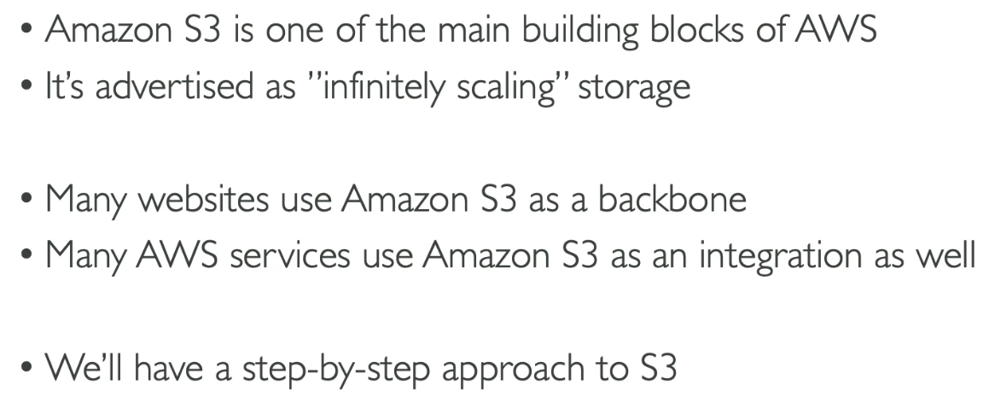Amazon S3 (Simple Storage Service) is a scalable, secure, and highly durable cloud storage service designed for storing and retrieving any amount of data from anywhere on the web. It organizes data into "buckets," which act as containers for files (called objects) that can range in size from a few bytes to terabytes. Each object is stored with a unique key for easy access. S3 offers various storage classes optimized for different use cases, from frequently accessed data (Standard) to archival storage (Glacier).

Used for backup and storage, disaster recovery, archive, hybrid cloud storage, application hosting, data lakes and big data analytics, software delivery, static website

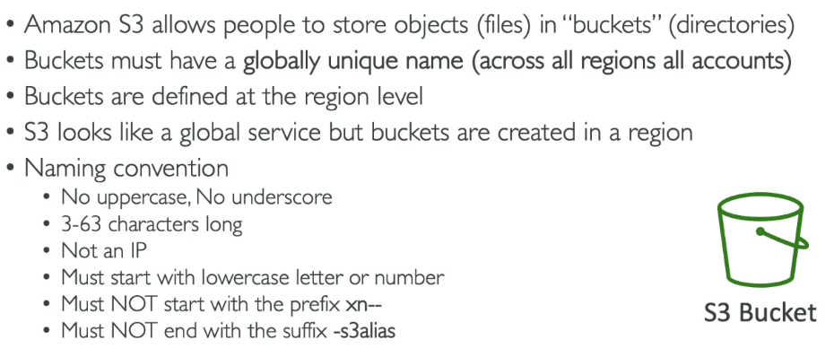Bucket:

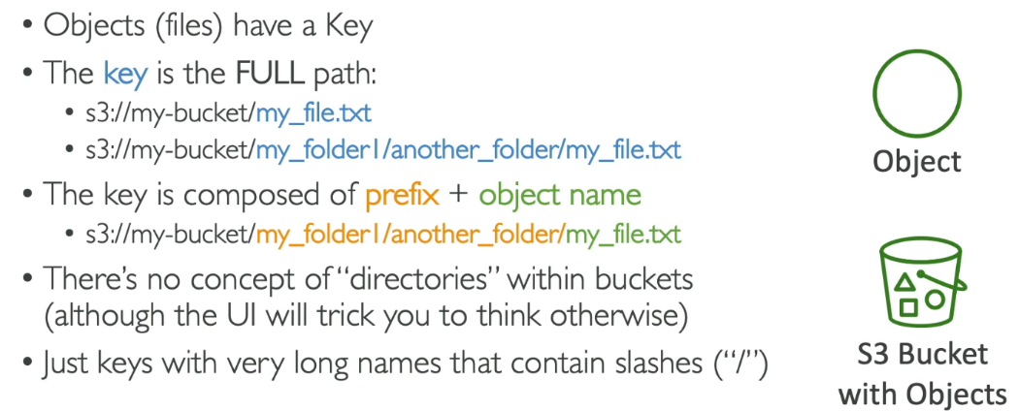Object:

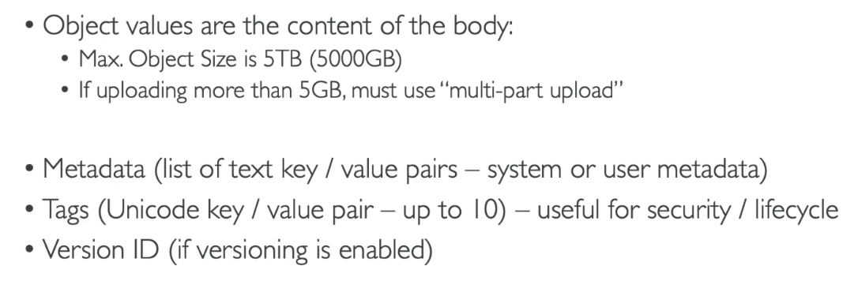

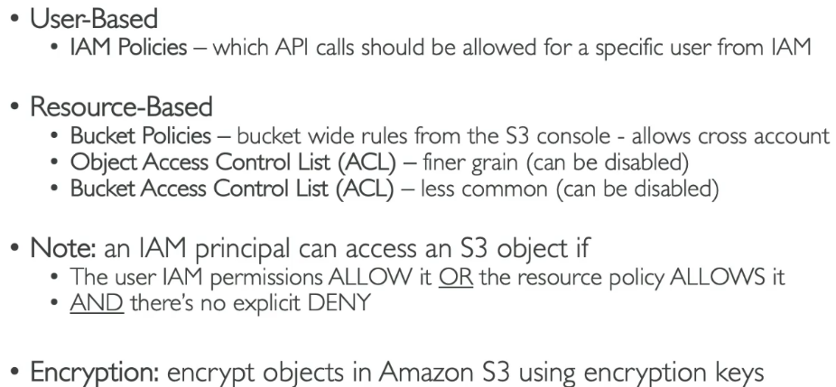 **Amazon S3 – Security**

In Amazon S3's security section, user-based security uses IAM policies to control what actions (like uploading, downloading, or deleting files) specific users or groups can perform on S3 resources. These policies define which API calls, such as GetObject (download), PutObject (upload), or DeleteObject (remove), are allowed for a user.

**Resource-based security** focuses on controlling access directly at the resource level, like buckets and objects, using bucket policies, bucket ACLs, and object ACLs:

**Bucket Policies**: These are JSON-based rules attached to an S3 bucket to control access for all objects within the bucket. They specify which users or accounts can perform actions (like read, write, or delete) on the bucket or its contents.

**Object ACL (Access Control List)**: These are permissions applied to individual objects. They determine who can access a specific file within a bucket and what they can do (e.g., read or write).

**Bucket ACL**: These define access permissions at the bucket level. They are simpler than bucket policies and grant basic permissions to predefined groups, like making a bucket or its objects publicly accessible.

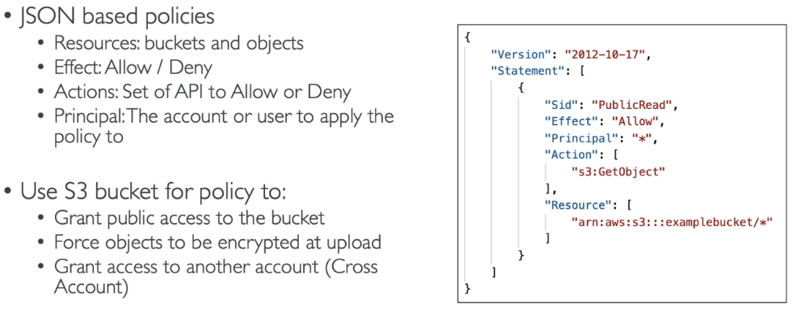S3 Bucket Policies

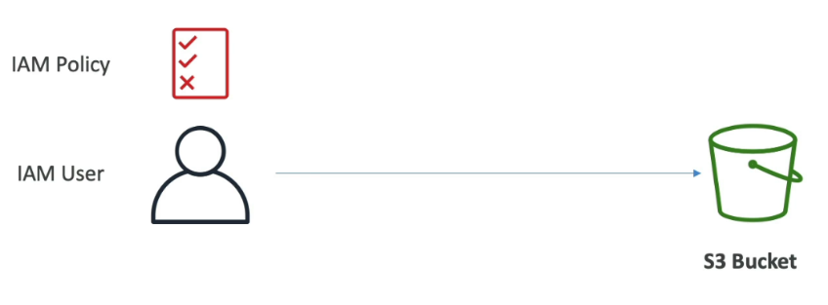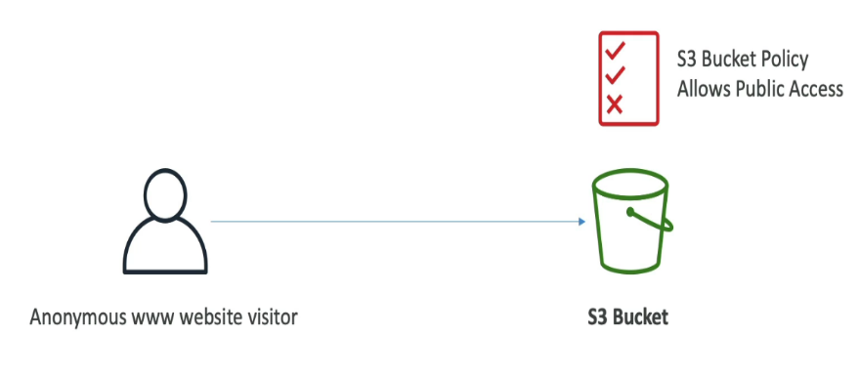

**Bucket Policy IAM Policy**

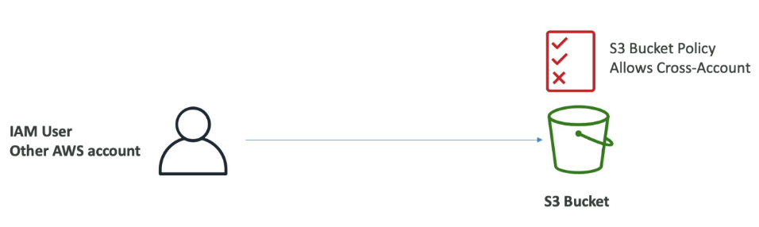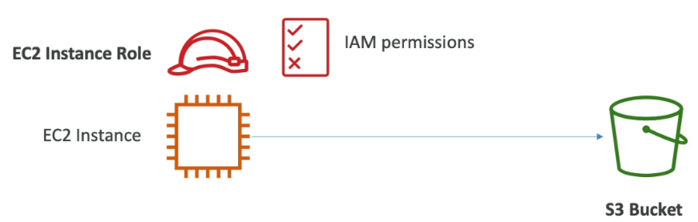**IAM Roles Cross-Account Access**

**Bucket Settings for Block Public Access**

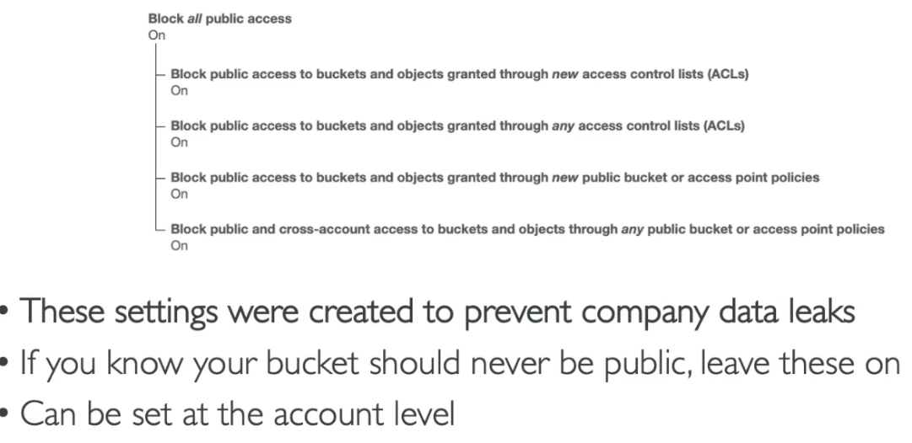The **Block Public Access** settings in Amazon S3 provide an additional layer of protection to prevent accidental exposure of your data to the public. These settings allow you to block public access at the bucket or account level by overriding public permissions granted through bucket policies, object ACLs, or bucket ACLs.

**S3 Static Website Hosting**

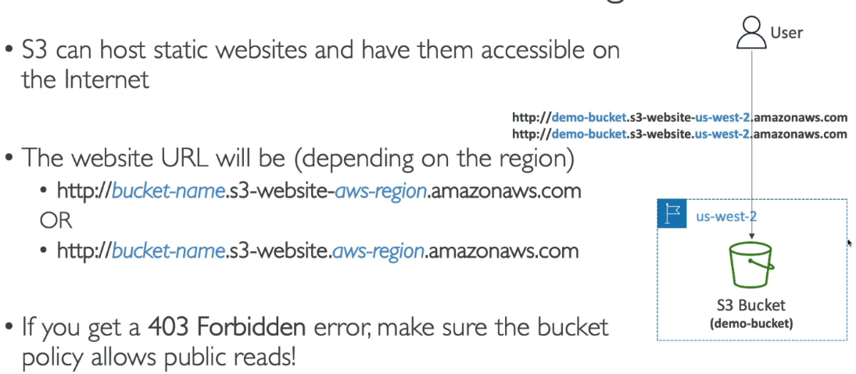Amazon S3 (Simple Storage Service) can host static websites by enabling the "Static Website Hosting" option on a bucket. To set this up, you create an S3 bucket with a globally unique name, upload your static files (HTML, CSS, JavaScript, etc.), and configure the bucket to serve content as a website. The bucket must have public read permissions, typically set through a bucket policy. You define an index document (e.g., index.html) and an optional error document (e.g., error.html). S3 assigns a public endpoint (e.g., http://bucket-name.s3-website-region.amazonaws.com) for access. For custom domains, you map the domain to the S3 endpoint using a DNS service like Route 53, often adding an SSL certificate via Amazon CloudFront for HTTPS support. Note that S3 is suitable only for static content since it does not support server-side processing

**Amazon S3 - Versioning**

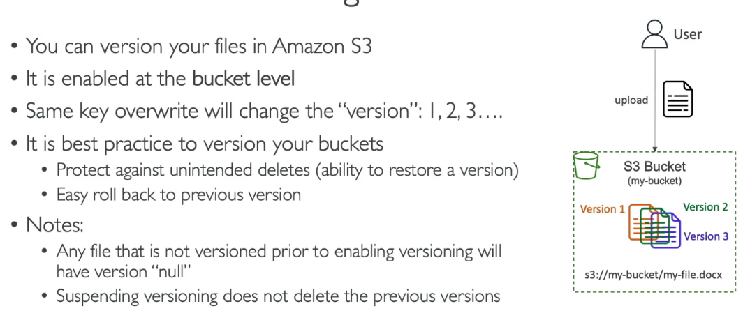Amazon S3 versioning is a feature that helps you preserve, retrieve, and restore every version of an object stored in an S3 bucket. When versioning is enabled on a bucket, S3 assigns a unique version ID to each object stored, allowing multiple versions of the same object to coexist. This is useful for recovering from unintended deletions or overwrites, as previous versions remain intact even after updates or deletions.

**Amazon S3 Replication (CRR & SRR)**

Amazon S3 replication is a feature that automatically replicates objects between S3 buckets in the same or different AWS regions. It supports two types:

**Cross-Region Replication (CRR)**: Replicates objects to a bucket in a different AWS region, useful for disaster recovery, compliance requirements, and improving latency for geographically dispersed users.

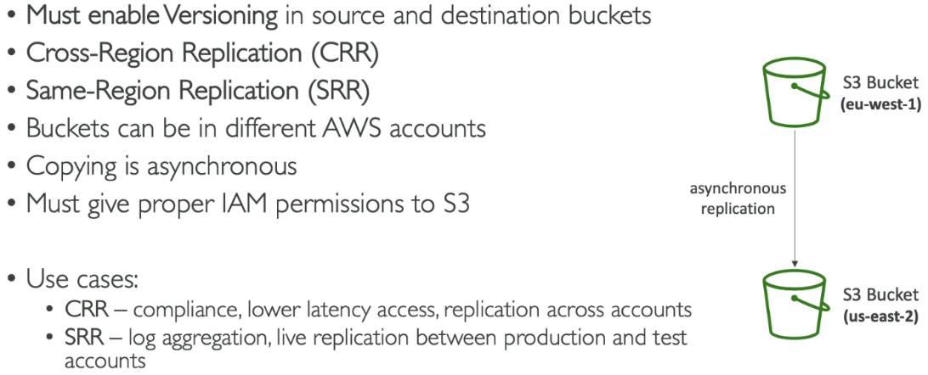**Same-Region Replication (SRR)**: Replicates objects to another bucket in the same region, helpful for workload isolation, data redundancy, or syncing across environments.

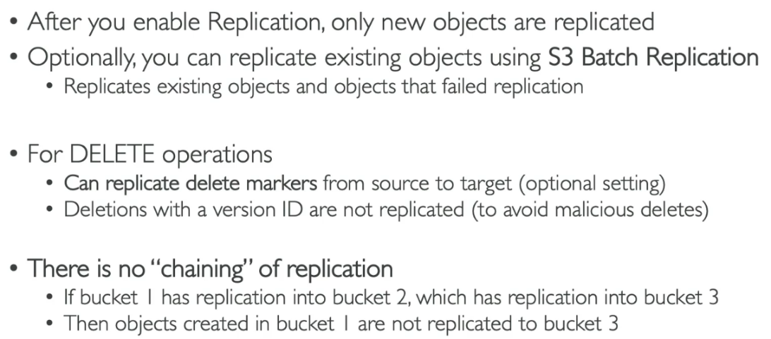 **Amazon s3 – Replication (Notes)**

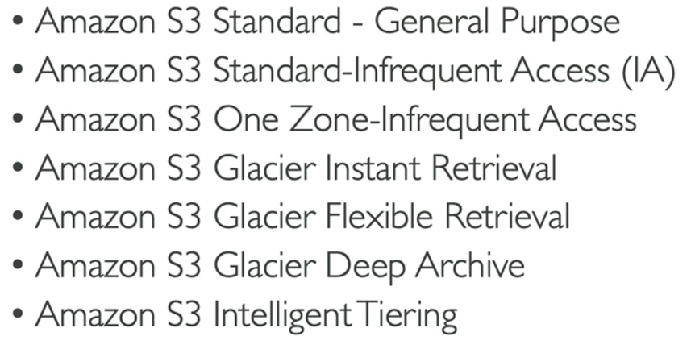 **S3 Storage Classes**

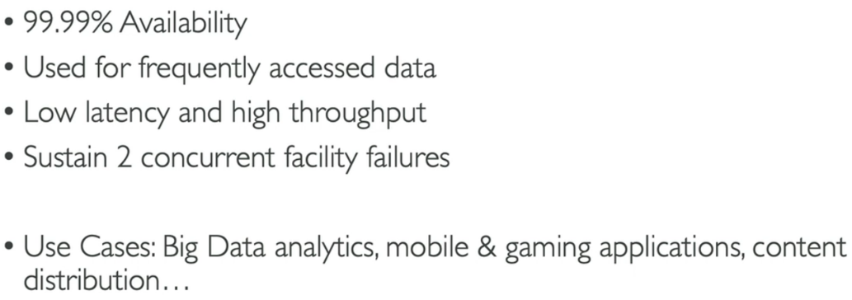 **S3 Standard**

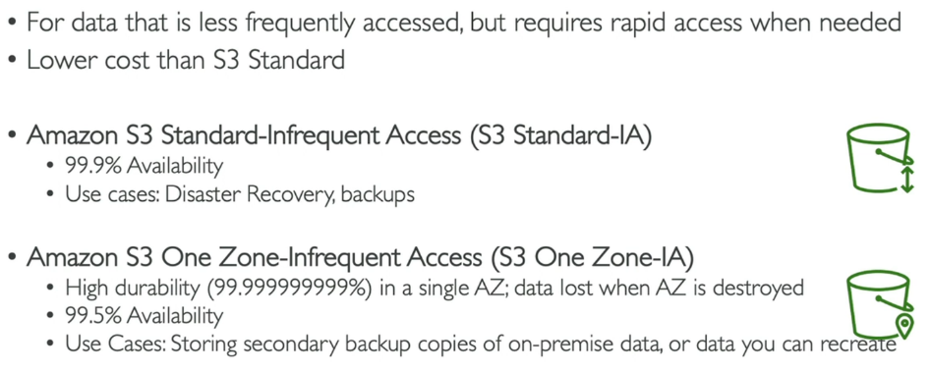 **S3 Infrequent Access**

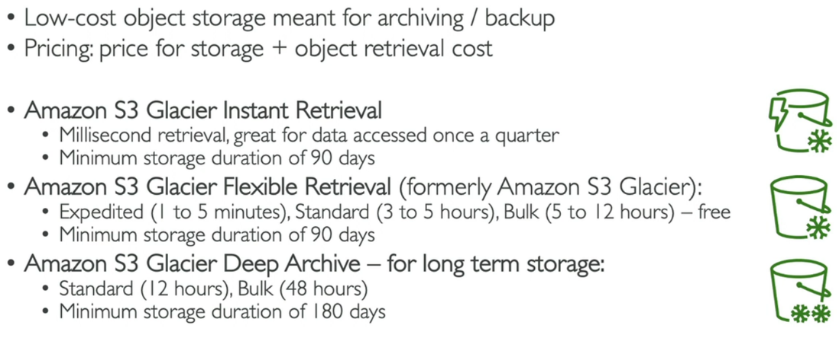 **S3 Glacier Storage Classes**

**S3 Intelligent-Tiering**

Amazon S3 Intelligent-Tiering is a storage class that optimizes costs by automatically moving data between different access tiers based on usage patterns. It has four tiers: **frequent access**, **infrequent access**, **archive access**, and **deep archive access**. Data initially starts in the frequent access tier, and S3 monitors access patterns. If an object isn’t accessed for 30 days, it’s moved to a lower-cost, infrequent access tier, and later to the archive tiers if it remains unused for longer periods. Objects are automatically moved back to frequent access if they are accessed again.

